Intro2Astro: Exoplanet Atmospheres Problem Set
July 29, 2025
Kadir Girici
Section I: Life & Habitability
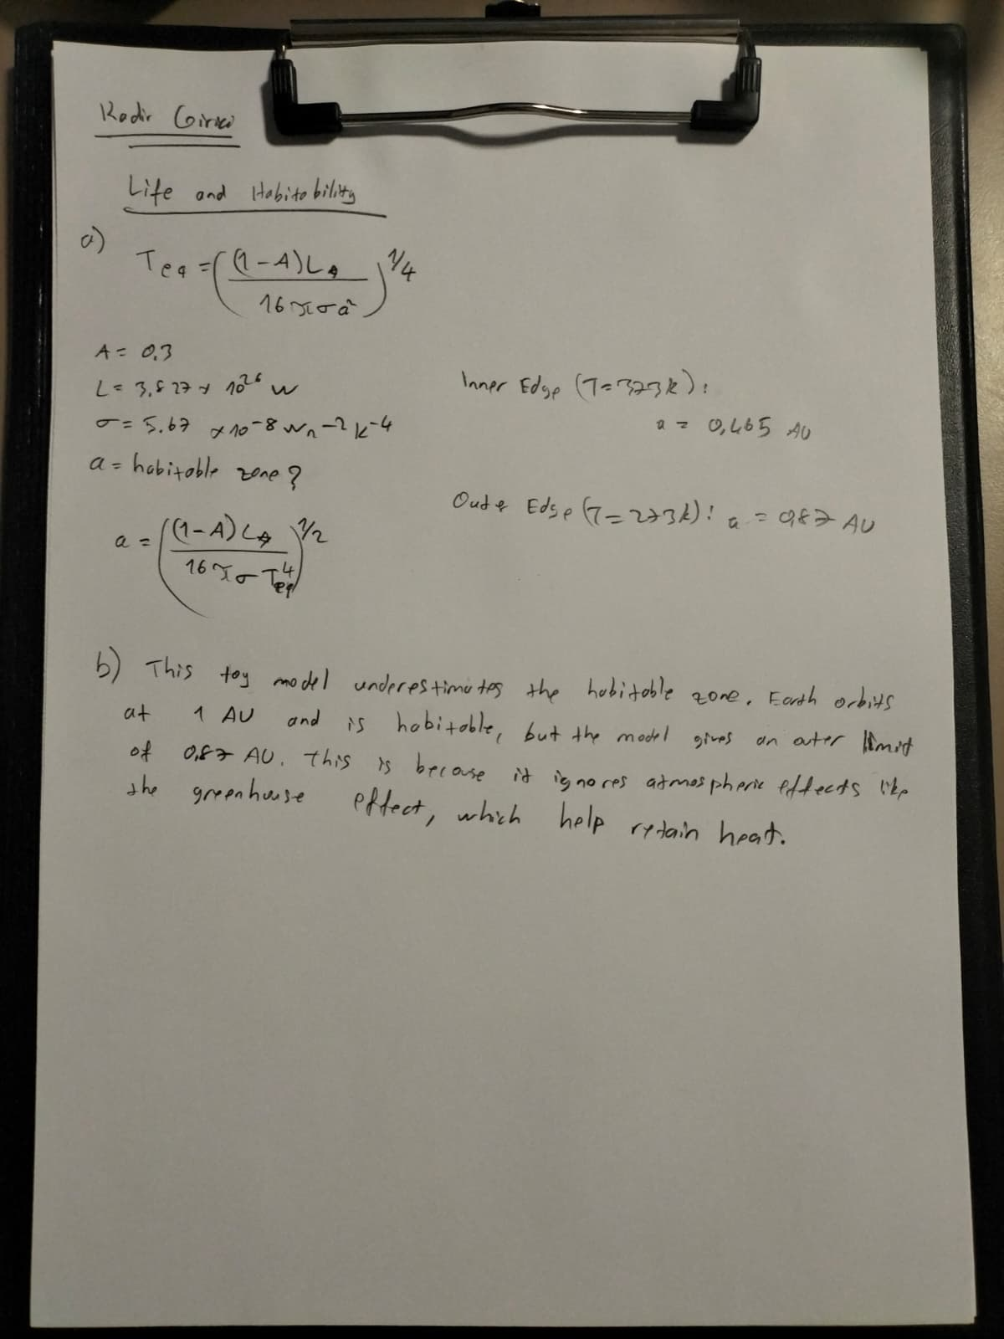
Section II: Interpreting Atmospheric Absorption Spectra

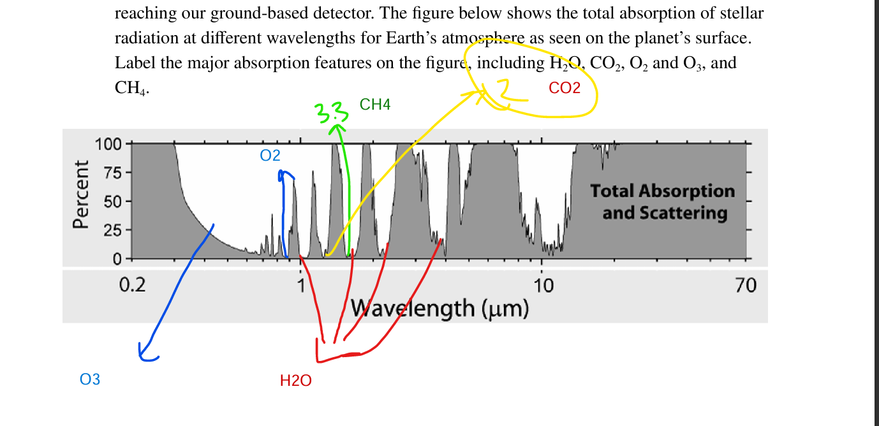

Section III: Characterizing Atmospheric Loss


